SESSION — ACTIVITY (20 MIN) • STUDENT HANDOUT • SLOT D
Redesign the Misleading Colored Chart
R.No: 11 | Reg. No: 192524114 | Name: Devamada Hemasree
Quick Concept: Using Colour in Charts
Colour should help the reader understand data faster. If it is chosen badly, it confuses or even misleads. There are three types of colour palettes:
Palette | Use it for | Example
Sequential | Ordered data from low to high | Light blue to dark blue
Diverging | Data with a real middle point (target, zero, average) | Blue – grey – orange
Categorical | Separate groups with no order | Distinct colours, max 5–6

Golden rules: (1) match the palette to the data type, (2) use colour only when it adds meaning, (3) avoid red–green pairs for colour-blind readers, (4) keep contrast with the background, (5) label everything clearly.
Chart 1: Revenue by Store
1. What is this chart trying to show?
The chart compares the revenue (in Rs lakh) of seven stores or groups, A to G. It shows which stores earn the most (about 90 lakh) and which earn the least (about 30 lakh). The main message is the ranking of store performance.
2. What's wrong with the color choice?
The chart uses a blue–white–red diverging palette, but revenue has no natural middle point, so the colours create confusion.
- Wrong palette type: diverging colours imply "above/below a midpoint", but no midpoint is explained.
- Redundant: colour repeats what the bar height already shows, so it adds nothing.
- Emotional bias: red feels "bad" and blue feels "good", so low stores look like failures.
- Low visibility: the near-white bar (about 58) fades into the background.
- Hard to read: similar light blues look alike, and the gradient legend is hard to match exactly.
- Extra issues: x-axis labels overlap, and the title says "Store" but the axis says "Group".
3. Propose a better color scheme (describe it in words):
Use one calm colour for all bars, such as a soft blue-grey. Highlight only what matters: the top store in dark blue and the lowest store in a muted orange-red. Sort the bars from highest to lowest and write the value on top of each bar. Remove the gradient legend and fix the axis labels. If the company has a revenue target, use a diverging scheme around that target (blue above, orange below, grey at the target) and label the target clearly.
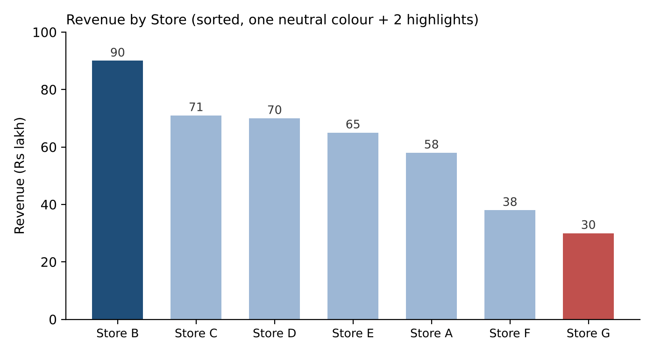
Figure 1: Redesigned Chart 1 (values read approximately from the original chart)
Chart 2: Course Difficulty Rating – Response Counts
1. What is this chart trying to show?
The chart shows how many students gave each difficulty rating, from 1 star to 5 stars. Most responses are 2 star and 3 star (about 67 and 64), and very few are 5 star (about 18). It shows how opinions are spread across the rating scale.
2. What's wrong with the color choice?
Each bar has a different bright colour (purple, orange, green, red, brown), like a rainbow. Ratings are ordered data, so this is the wrong choice.
- Order is lost: random colours look like unrelated groups, not a scale from 1 to 5.
- False meaning: green on 3 star and red on 4 star suggest "good" and "bad" without any reason.
- Not colour-blind friendly: red and green are hard to tell apart for many people.
- Distracting: bright orange and green pull the eye to 2 star and 3 star, so they look more important.
- Unnecessary: the x-axis already names each bar, so the colours add no information.
- Unclear scale: the chart does not say whether 1 star means easy or hard.
3. Propose a better color scheme (describe it in words):
Use a sequential single-colour palette: light blue for 1 star, getting darker step by step to deep blue for 5 star, so darker means harder. This keeps the order clear and is safe for colour-blind readers. Another good option is a diverging scheme with blue for easy, light grey for the neutral 3 star, and orange for hard, because a rating scale has a natural middle. Also label the axis ends ("1 = Very Easy, 5 = Very Hard") and show the count on each bar.
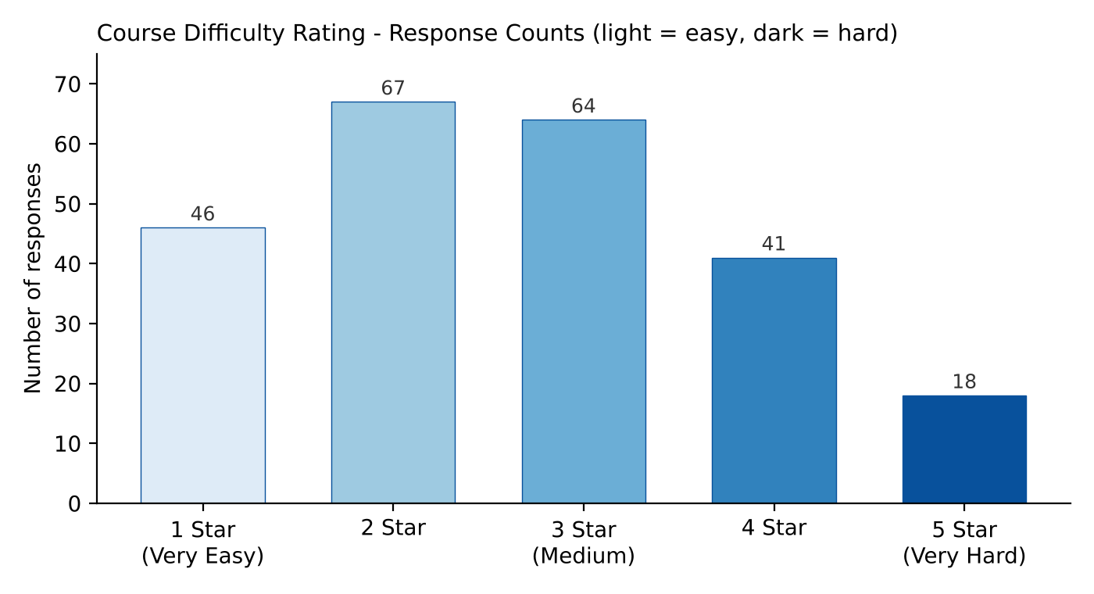
Figure 2: Redesigned Chart 2 (values read approximately from the original chart)
Summary
Chart | Main colour problem | Fix
Chart 1 | Diverging palette on data with no midpoint; red/blue judgement; faint bar | One neutral colour with 2 highlights; sort bars; add labels
Chart 2 | Rainbow colours on ordered ratings; red–green clash | Light-to-dark single-hue scale; label scale ends

Conclusion: Good colour choice means the right palette for the data type, simple and meaningful colours, and clear labels. The chart should be easy to read for everyone, including colour-blind readers.

